**Lab 1**

**Problem 1. Building an ER model for a hospital**1. Finding Entities, key Attributes and related Attributes:

* Hospital
* Doctors: doctor code (primary key), doctor's name, date of employment, and specialty.
* Patient: patient id (primary key) and patient name
* Treatment:doctor code, patient id, date of treatment, duration of treatment and results. (doctor code and patient id is group of (primary key))

2. Finding Relationships

* Doctor – Patient: Admit.
* Patient – Doctor: treated by.

Cardinality

* Doctor – Patient: One to Many (Admit)
* Patient - Doctor: Many to Many (Treatment)

3. Finding weak Entities and weak Relationships (if any)

* Weak entities: Treatment
* Weak relationships: Treatment - Doctors, Treatment – Patients

4. ER Diagram

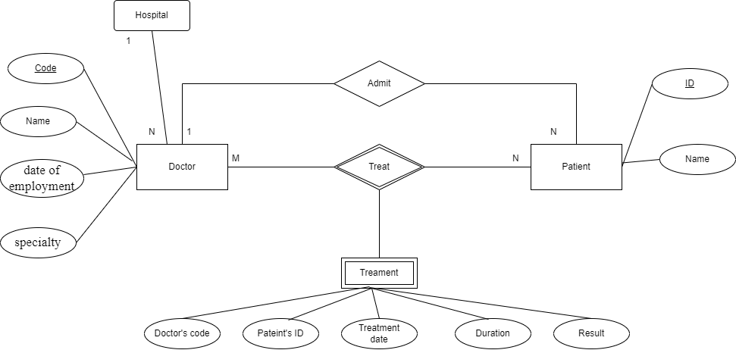

**Problem 2. Building an ER model for a University**

1. Finding Entities, key Attributes and related Attributes:

* University:
* Faculty: Faculty Code(primary key), Faculty Name
* Class: Class code(primary key), Class name, Wholesale number
* Student: Student ID(primary key), Full name, Date of birth, gender, address, graduation point.
* Subject: Subject code(primary key), Subject name, number of credits
* Library card: Card number(primary key), Issue date, Expiration date.

2. Finding Relationships

* Student – Class: placed in
* Student – Subject: participate

Cardinality

* Universiy – Faculty: One to Many
* Faculty – Class: One to Many
* Faculty – Student : One to Many
* Class – Student: One to Many
* Student – Subject: Many to Many
* Student - Library card: One to One

3. Finding weak Entities and weak Relationships (if any)

* Weak entities: Exam score
* Weak relationships: Student – Subject

4. ER Diagram:

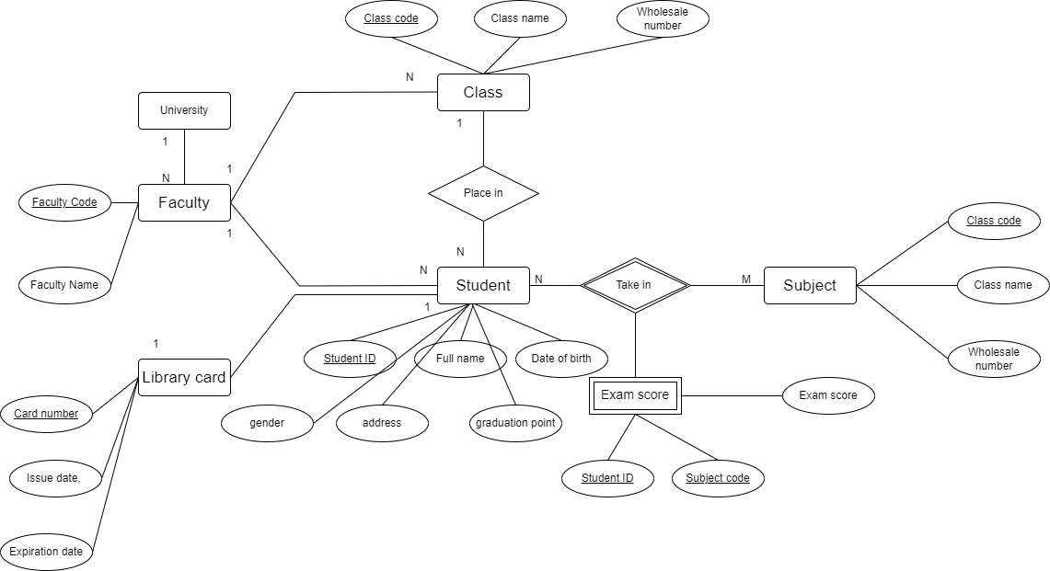

**Problem 3. Building an ER model and relational data model for 1 hotel needs to store information as follows:**1. Finding Entities, key Attributes and related Attributes:

* Hotel
* Room: room code (primary key), room name, floor(foreign key).
* Floor: floor code (primary key), floor name
* Guest: identity card (primary key), full name, phone number, room code(foreign key)
* Service: : service code (primary key), service name, service amount
* Invoice: Invoice code(primary key), identity card code (foreign key), customer name, arrival date, departure date , room number(foreign key), total room amount, service fee, total payment.

2. Finding Relationships

* Room – Floor : located
* Guest – Room: Rent
* Guest – Service: Book

Identify the Cardinality

* Hotel – Room : One to Many
* Floor – Room: One to Many
* Guest – Room: One to Many
* Guest – Service: Many to Many
* Service – Room: Many to One
* Guest – Invoice: One to Many
* Invoice – Service: Many to many

3. Finding weak Entities and weak Relationships (if any)

* Weak entities: InvoiceService
* Weak relationships: Invoice – Service

4. ER Diagram:

